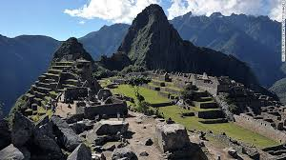
Name__________________________________ Period______
World Literature Travel Activity
Directions: Research your dream vacation outside of North America (Canada, the US, the Caribbean and Central America are off-limits.) Use the sheet below to record your information.
Using imagery and sensory detail, create a brief, albeit highly interesting fictional THREE DAY travel blog to the destination of your choice and a summary of what you did when you visited those places. In your fictional blog post, include the cost, best places you visited, and pictures of the places you visited. See example.
- Browse possible destinations. Record a few different places where you would like to travel in the space below. Circle the one you’ve decided to research. Determine a place outside of the United States that you would like to travel.

- Research a travel site such at Travelocity.com to determine the flight of a plane ticket there. Use the dates for Spring Break this next year for ticket prices (Spring Break falls on April 3-April 7, 2017). Record how much your round trip tickets might cost you in the space below. Then, as a part of Day 1 of your blog post, talk about the prices of the tickets.

- Find out how much it would cost to stay five nights in a hotel. This might still be on Travelocity.com, so you can do a little research on the same site for this as well. Record the prices below. Write down the various hotels you looked at and the prices. Find affordable prices, not outlandish prices, and write about your hotel stay as a part of your blog post.

- Now leave Travelocity and look up your city or country on the Internet. Find cool places you would like to visit, as well as pictures of those attractions to put in your blog post. These should NOT be boring places like the capitol or a local museum. They could be amusement parks (Watercube Water Park in China), prominent landmarks (Christ The Redeemer in Brazil), traditional events (Bullfight in Spain), or interesting historical sites (Machu Pichu in Peru). You should find 5 activities that you might visit while you are in the city or region and record them below. Write about the activity and what it includes as a part of your daily activities in your faux blog post.

- Now look for a possible restaurant in the city where you are staying on Yelp.com. See if the restaurant has a menu. This should not be McDonalds. Although McDonalds can actually be quite different outside of the U.S., I’d like you to look for a restaurant that you might visit while you are in the city and see if you can pull up a menu. Write down the name of the restaurant and your visit to it here and in your fictional blog post..

- Finally, research one piece of historical information about the city you will be visiting. When I lived in El Salvador, I researched some pretty interesting history that helped me appreciate what I was going to be seeing. I found out that the country had recently ended a bloody Civil War and that’s why there where buildings in ruins and guys walking around with machine guns and machetes everywhere. Look for one piece of history and record one paragraph of history about a building, war, or person below that would help you if you visited that city. Incorporate the piece of information in your blog post.

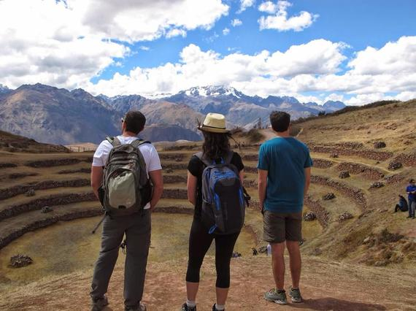
- Finally, write up a three-day fictional travel log or mock blog post describing to us your visit to your destination of choice. Use description and sensory detail to describe what you saw the days that you were there. You’re NOT going to want to tell us just what you did, but what you saw. See an example below. Be prepared to read your travel log as you show us the pictures of the different places you visited.

Day Two: Macchu Pichu Day! No matter how beautiful everything was (in Peru) until this point, the site of this place was almost too much to handle. You can look at a million pictures of a place, read a thousand books about it, explore the incredible areas surrounding it and think you've seen enough, but embarking on the sight of Machu Picchu with your own eyes for the first time is like nothing else.
We hiked 8,000 feet up crumbly, decaying rock steps early Tuesday morning to get to the summit. Looking down at the lush, green valley below, as well as the zig-zagging Hiram Bingham highway, I couldn’t help but smile. After I got over my fear of heights (the hike was precariously close to a cliff and there was one dusty boulder so steep that we had to slide down it or we would have died), I began to enjoy the scenery around us, especially when we reached the Inca terraces and bridge. (One picture you may not want to take: all of the people taking nude selfies up here. #Crazy).
The bridge was the only way into Macchu Pichu. It was straight out of an Indiana Jones movie. Frayed rope, rotting wood, and stone pillars cut right out of the mountain. I halfway expected Gandalf to scream, “You shall not pass!” as I crossed the piecemeal midsection of the bridge. Crossing into the village, I was blown away by how clean and authentic it was. The houses still had broken pieces of clay potter and jagged arrowheads lying in their crumbled ruins, remnants of a people long since gone. I will never forget when we climbed the top of the highest building in the city to find a tattered button doll propped up in the corner of the house, like some disobedient child. Macchu Pichu was a day I will never forget.

