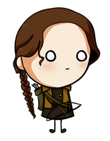
Parody and Fanfiction: Hunger Games Final Project (Worth 100 Points)
Due: Due October 25th (All Drafts Edited)
Step One: Understanding Fanfiction--Fanfiction is fiction written by a fan of, and featuring characters from, a particular TV series, movie. GREAT fanfiction is thoughtful and interesting and significantly adds to the story canon. There have been an innumerable amount of fanfiction pieces and parodies created surrounding the Hunger Games; some good and some bad.
Step Two: Partner Fanfiction Brainstorm and Ideas Writer’s Notebook—With a partner, brainstorm ideas for your final project on a piece of lined paper. This is your writer’s notebook for today. Brainstorm characters, ideas, and settings that you think are interesting from the Hunger Games series and summarize their backstory in 1 paragraph at the bottom of your writer’s notebook. Make sure that you introduce the story well and add detail and specifics to the story. Your summary needs to have facts and be based on an idea from the series. The story will also need a conclusion.
Step Three: Understanding the Hunger Games Final Project: Using the understanding you have from the Hunger Games, pick individually (or with a partner) a fanfiction story that significantly adds to the storyline of the Hunger Games (like the Hanging Tree clip and other fanfiction pieces I will show you) or a parody that has yet been created that thoroughly and tastefully mocks an aspect of the story. Your story must be based on facts in the Hunger Games; you will highlight these facts in your story. More importantly, your piece MUST teach a lesson about life and use language and have moments that teach that theme throughout the story.
Your story will be 5-8 paragraphs long and should be written as a lengthier summary. Your summary needs to be objective and should teach a life lesson about how people should act or why something happens to certain people. You will need to choose words and use language that teach that life lesson. You will write and revise three separate drafts before you are done. Don’t just turn in your first draft unchanged as your final draft.
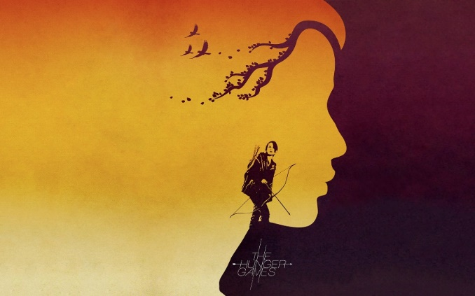
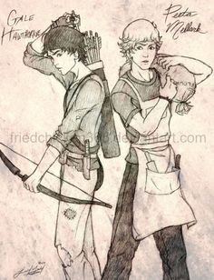
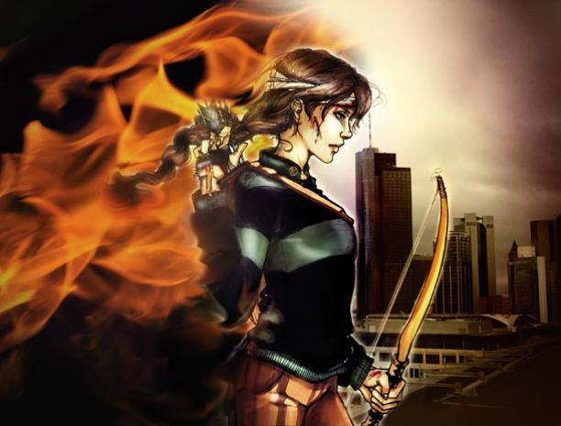
You will need to approve your project before you create it and you must include a reflection of your work. If I were you, I would both work on the story, but put one person in charge of the reflection and one person in charge of the final draft of the story. Shy away from cliché, stereotypical, and uninformed projects. You’re welcome to work with a partner, but if you choose to do so, you will need to produce a significant project in order to show that you both worked on it and spend time on it.
