Rogue One Field Trip Response Paper
Star Wars: Lost Stars Unit

Response Paper Due Wednesday, February 1
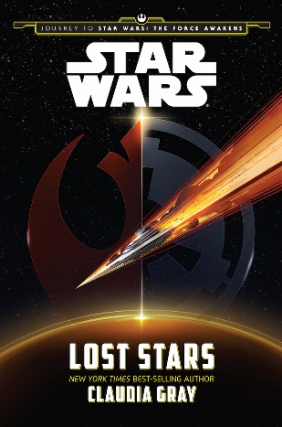
Assignment: One (Full) Page, Double-spaced Response Paper

One of the aspects of the new Star Wars universe and Rogue One that I appreciate is how connected the stories are to each other and how much the authors of the new canon and the directors of the movies and TV series can pay homage to other stories and even Star Wars: Legends while still creating their own story. As you watch Rogue One today, choose a moment in the movie that connects to our novel, Lost Stars, and/or another Star Wars story, like Star Wars Rebels or A New Hope, and discuss how Gareth Edwards incorporated the element into the story and whether or not it was effective. Then, argue whether or not you liked the movie with concrete examples and heavy explanation.

Rogue One Field Trip Response Paper
Star Wars: Lost Stars Unit

Response Paper Due Wednesday, February 1

Assignment: One (Full) Page, Double-spaced Response Paper

One of the aspects of the new Star Wars universe and Rogue One that I appreciate is how connected the stories are to each other and how much the authors of the new canon and the directors of the movies and TV series can pay homage to other stories and even Star Wars: Legends while still creating their own story. As you watch Rogue One today, choose a moment in the movie that connects to our novel, Lost Stars, and/or another Star Wars story, like Star Wars Rebels or A New Hope, and discuss how Gareth Edwards incorporated the element into the story and whether or not it was effective. Then, argue whether or not you liked the movie with concrete examples and heavy explanation.

Rogue One Field Trip Response Paper
Star Wars: Lost Stars Unit
Response Paper Due Wednesday, February 1

Assignment: One (Full) Page, Double-spaced Response Paper

One of the aspects of the new Star Wars universe and Rogue One that I appreciate is how connected the stories are to each other and how much the authors of the new canon and the directors of the movies and TV series can pay homage to other stories and even Star Wars: Legends while still creating their own story. As you watch Rogue One today, choose a moment in the movie that connects to our novel, Lost Stars, and/or another Star Wars story, like Star Wars Rebels or A New Hope, and discuss how Gareth Edwards incorporated the element into the story and whether or not it was effective. Then, argue whether or not you liked the movie with concrete examples and heavy explanation.

