Frankenstein’s Monster Assignment: The Origins of Science Fiction
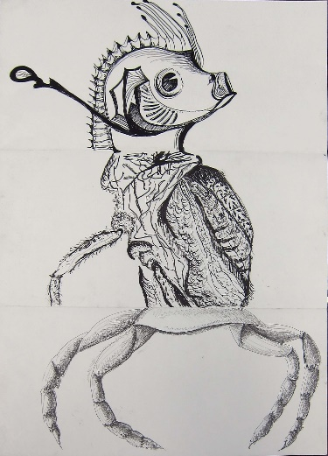
Since the creation of a mismatched, grotesque monster started the scifi era, that’s how we’ll start this Scifi term off with creating our own monster. Get with a partner and draw a terrible monster that has elements in it of things you are deathly scared of, like Frankenstein’s monster, or something of your own making.
Get a piece of computer paper and fold it into three sections. Make sure all of the sections have an equal amount of space. On the top section, draw the head and fold the section over so the next partnership can’t see the picture and pass it. On the middle section, draw the rest of the upper torso to the waist and fold it over. On the bottom section, draw everything below the waist and fold it over and pass it. When you unfold the entire art piece you get one cohesive monster that features the imagination of all three groups put together in a Frankenstein mish mash. After you’re done, write a brief, two paragraph bio on the back and story about your monster and be prepared to present it.
Frankenstein’s Monster Assignment: The Origins of Science Fiction
Since the creation of a mismatched, grotesque monster started the scifi era, that’s how we’ll start this Scifi term off with creating our own monster. Get with a partner and draw a terrible monster that has elements in it of things you are deathly scared of, like Frankenstein’s monster, or something of your own making.
Get a piece of computer paper and fold it into three sections. Make sure all of the sections have an equal amount of space. On the top section, draw the head and fold the section over so the next partnership can’t see the picture and pass it. On the middle section, draw the rest of the upper torso to the waist and fold it over. On the bottom section, draw everything below the waist and fold it over and pass it. When you unfold the entire art piece you get one cohesive monster that features the imagination of all three groups put together in a Frankenstein mish mash. After you’re done, write a brief, two paragraph bio on the back and story about your monster and be prepared to present it.
Frankenstein’s Monster Assignment: The Origins of Science Fiction
Since the creation of a mismatched, grotesque monster started the scifi era, that’s how we’ll start this Scifi term off with creating our own monster. Get with a partner and draw a terrible monster that has elements in it of things you are deathly scared of, like Frankenstein’s monster, or something of your own making.
Get a piece of computer paper and fold it into three sections. Make sure all of the sections have an equal amount of space. On the top section, draw the head and fold the section over so the next partnership can’t see the picture and pass it. On the middle section, draw the rest of the upper torso to the waist and fold it over. On the bottom section, draw everything below the waist and fold it over and pass it. When you unfold the entire art piece you get one cohesive monster that features the imagination of all three groups put together in a Frankenstein mish mash. After you’re done, write a brief, two paragraph bio on the back and story about your monster and be prepared to present it.

