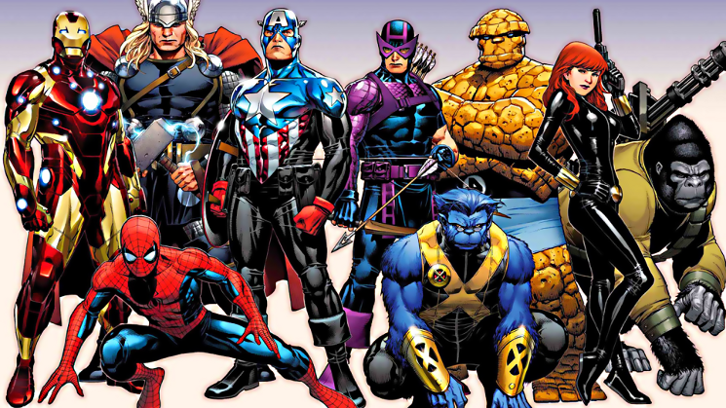
HEROES
Two heroes enter the stage. The hero on the right is wearing a red cape. He has a chiseled chin and bulging muscles. You know, if prompted to, he could stop a speeding bullet or leap a tall building in a single bound. The hero on the left is wearing a simple dress and a cloth wound tightly around her head. Her face and hands are wrinkled from the years she has spent laboring in the ditches of Calcutta, caring for the sick and dying. She has touched the lives of millions worldwide, but her footing is so weak she can barely stand.
Which one is the real hero?
Obviously, there are many different definitions to the word hero. For some it might mean a political or religious figure. For others, a beloved relative or friend. It might even mean comic books and spandex to few. But—
Some heroes don’t have supernatural powers. Some heroes haven’t changed the world.
Some heroes aren’t even famous. What’s the tried and true qualifier for a hero then? At some point a hero has impacted another person’s life. Heroes are personal. Affecting the lives of thousands is great, but one is enough.
Heroes are trailblazers. Heroes overcome great challenges. Heroes have all the weaknesses the rest of us have—greed, fear, hate—but they have mastered and defeated them. Heroes make their heroic deeds look easy, even though they’re not.
Many people have asked, “Are heroes born or made?” Does everyone have the hero capability lying dormant inside him or her? Or are heroes only a certain type of people, the ones destined to do great things? (You’ll learn what the Greeks thought on the subject soon.) Don’t ordinary people do heroic deeds all the time? They stop a child from drowning. Their kind words keep a woman from committing suicide. They save a man from going hungry. Until they were placed into these situations, they might not have known if they were heroic or not.
Our culture talks about heroes so much, it’s almost cliché. When you’re asked to write about heroes for the five-hundredth time, you might roll your eyes. But actually this topic is one that should be run into the ground. We should never forget the sacrifices made in the past and in the present to preserve their safety, freedom, and happiness. If writing “My Hero Is…” essays until a hand falls off is the way to remember that, so be it.
Heroes inspire more heroes. It’s a side effect of their actions. Seeing them do their best, inspires us to do our best. The heroic spirit is kept alive and reborn for a new generation.
All of these points are important to consider. Someday you might want to be a hero yourself. You’ll need to know how this whole hero thing works. Along the way, you might also discover that heroes aren’t confined to the lofty heights of Mount Olympus or even the Bat-Cave. They might be everyday people right here on earth, a lot closer than you thought. Maybe your definition of a hero doesn’t match this one. Maybe you want more qualifications. For you heroes may only be linked to sports or music or politics. Since heroes are personal, it’s up to you to determine your personal definition. That way they’ll be easier to spot when they come along.
What does it take to be a hero for you?

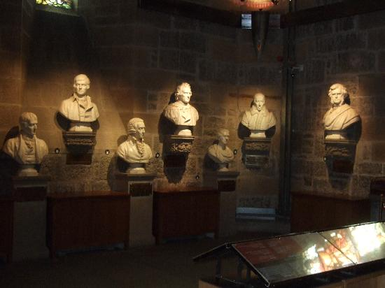
Fellowship of Heroes
Discussion
A new museum is being opened. It is solely dedicated to ten heroes who have shaped literature. You and your classmates have been selected to decide which ten figures will be inducted to The Hall of Heroes. Each person should nominate one person. Discuss your choice with your classmates. Then vote on the ten inductees. If there is a discrepancy, continue to vote until you reach a consensus.

▪ What were some of the different qualifications used to justify your nominees?
▪ Is there a quality every nominee has in common?
▪ Who are the heroes of your society? How do you tell? Explain.
▪ Are heroes born or made? Defend your answer.

Fellowship Of Heroes
Drawing Assignment

Decide upon your own fictional Hall of Heroes. The characters must be heroes from movies, stories, or literature. Use the same criteria you did to figure out your real heroes. Write them down with an explanation for each choice. Rank them in greatness. Be prepared to share. For your assignment, go ahead and draw or create a picture with your hall of heroes, including what the hall looks like, statues of each character, and name plaques. 50 Points Extra Credit to the best drawings.

