Why Fantasy Matters: Fantasy Final Project Description (100 Points)
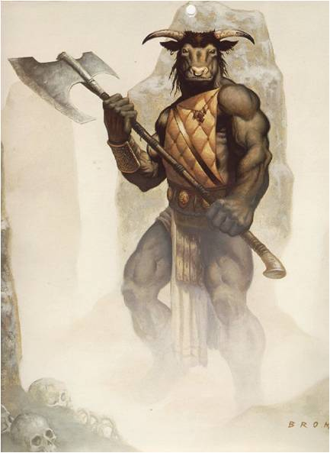
Directions: After you’ve brainstormed a list of your favorite stories, and moments, in fantasy literature, propose a project you can create that argues why fantasy matters. Your project should prove with specific evidence that fantasy does matter. You can choose the method and madness of your project, but make sure it is a doable project that proves your argument. You will present your project the last day of the term. (On a side note, your book share is due the second to last day of the term).

