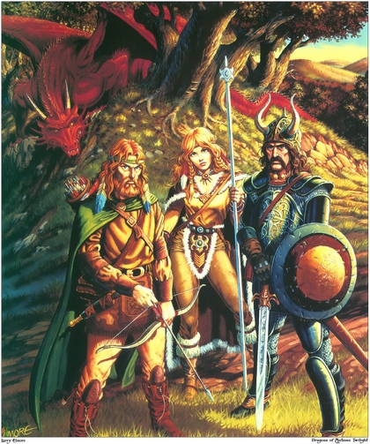
Fantasy Character Creation Assignment

Name_____________________
Character Name____________
Character Race_____________

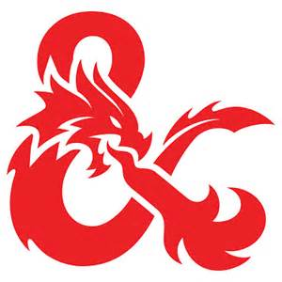
Fantasy Character Card

Character Picture
(Paste Here)
Name: M F

Race:

Ability:

Weapon:

Age: Height: Weight:
Arcana: (Pick Two)

Strength: Weakness:

Familiar Pic
Familiar Picture
(Paste Here)
Characteristics: (36 Points)
Agility: Speed:
Smarts: Strength:

Arcana:

Armor:

Fantasy Character Creation Choices

Assignment: On a lined sheet of paper, brainstorm some ideas about a character you would like to create for the fellowship assignment. You are required to pick a character’s race, a special ability, a weapon, and a familiar (animal companion). Additionally, you will need to fill out the rest of the character card. Instructions follow.

Step One: Choose a race for your character. If you would like, you can pick a half-blooded character. However, the character you choose must be on this list. You cannot come up with another character you know about. This list is the end-all for this assignment.

Races
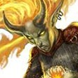
Demon—An evil spirit or devil, especially one thought to possess a person or act as a tormentor in hell. Demons can be controlled by magic users even though they have almost unlimited magical powers themselves. They are almost always evil and cannot live on the Earth. They can only summoned by a powerful mage.

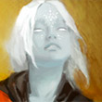
Deva--Devas are immortal spirits which will be reborn over and over again whenever the deva dies, but instead of being reborn as a baby, devas are reborn as adults in a sacred place.
Devas no longer have lands or masters they're bound to, which has led to many devas searching for new causes to serve, while others enjoy their life of freedom. Devas have an urge to love, live and excel in whatever situation is thrown at them. They're intensely fascinated with the world and its inhabitants. However, devas do, if only vaguely, remember the lives they once lead in servitude of the gods and the wars they fought against the forces of evil. Devas are strongly committed to good causes, which can come in many forms. This commitment comes partly out of fear, as a deva whose soul becomes corrupted by evil could be reborn as a rakshasa, which is a race of deceitful, villainous tiger-like humanoids.
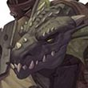
Draconian—Draconians are related to dragons, but this relation leaves much to desire when you compare the two. They focus on the grudges they have with other races instead of power or gain. Draconians don't make very great soldiers, but they're great ambushing and trapping. Any tactic that poses the least threat to themselves is the best in their eyes, especially if it means harming whoever their victim is. Also, to add insult to injury, Draconians turn to stone when they die.
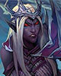
Drow--The drow are a race of evil elves, cursed with their appearance by deities of the good elves after the drow followed an vile goddess into a path of corruption. Despite their curse or perhaps due to it, many of the drow continue to worship evil, although there are some drow who choose a more neutral side to life. The drow possess a unique sign language which allows them to communicate over larger distances, as long as their remain in vision of each other. These distances can reach up to 120 meters, making them very dangerous to anybody in their way.
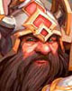
Dwarf—Dwarves were once a proud united race, but years of wars with orcs and goblins, internal conflicts and other struggles have dispersed them across the lands. New lands have given them new appearances, though many still share the typical dwarven look, no matter their size, hair or skin color. Dwarves are proud, brave, stubborn and tenacious, but, perhaps above all, they are suspicious of others and they keep a grudge. A dwarf will not trust you unless you have proven beyond a shadow of a doubt that you're trustworthy. Until then a dwarf will keep you at length, always prepared for the worst in you. Dwarves keep a grudge, if you betray them, no matter how big or small the betrayal, they will get even one way or another. This has also fueled their hatred for orcs and goblins, whom they will slay with pleasure. Orcs, goblins and various other races are considered to be a plague which must be purged, before they can grow in numbers and become overwhelming.
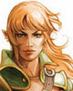
Elf—Elves are one with nature and will do anything they can to protect it. Their archery and tactical skills are among the best, which they gladly use in combination with agility and cunning to protect what they love. The elves themselves live in forests. Their homes are made through rituals in order to form living wood structures. They only take from nature what they need and even though they sometimes kill an animal for resources, they make sure they use everything.Elves are very calm and patient, they won't let their emotions run wild. This makes them great fighters as they're always able to assess a situation calmly. However, many elves aren't fond of other races. Though plenty have decided to work with them for their own survival and friendships can grow from there.
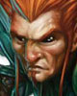
Gnomes--The gnomes are true tricksters. Their small size and sense of humor are often used to deceive both friend and enemy and to hide their true intentions. However, although they do have their suspicious of taller races, most gnomes mean no harms and only wish to joke around. Gnomes are very curious, which makes them great engineers, as they're always trying out something new, even if it's just to see how other gnomes or other races would react. Their love of engineering and their love of gems has strengthen their relationship with dwarves, both of which also hate goblins, orcs and other foul creatures.
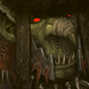
Goblins--Goblins are the cousins of the other Greenskins, the Orcs, but they're far smaller and far more numerous. They're vicious, treacherous and evil, but they're also more intelligent than their larger cousins, the Orcs. Because of this and because Orcs are quite lazy, the goblins do most of the crafting, building and other similar tasks.

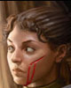
Halfling--Halflings are perhaps the friendliest kind you will come across. They're known for their great spirits even in the most dire of circumstances. They're carefree, brave and curious, but most of them are content with a life full of simple pleasures. Their curiosity and bravery can make them great adventurers, but they do tend to avoid risky situations. Their small size often helps them avoid such situations, but they don't like being judged purely based on their height. As one may find out, halflings are capable of great feats, no matter their size.
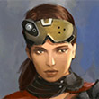
Human--Just like the real world, humans come in many different shapes, types and sizes. They have countless different ambitions, dreams and goals, what they lack in strength they make up for in determination and while their hearts may not always be pure, many will do anything to get what their heart desires. Humans could make the perfect or worst party member. They could be a glorious leader or filthy backstabber. They could do what's best for them or what's best for the group. Their appearances can be deceiving, so you rarely know if you can fully trust your fellow party member.
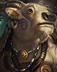
Minotaur—Minotaurs are bull-like humanoids with both a strong urge for violence as well as a strong conscience. These two contradicting aspects mean a minotaur often has to try to balance between the violent urges and temptations and between the will to do good. Not all minotaurs manage to resist the temptation of their more violent urges, but those who do possess great self-control, which is also reflected in their society and daily lives. Perfecting skills and mastering techniques give minotaurs great pleasure and is perhaps one of the most important parts of resisting other urges. Labyrinths are also important to minotaurs in the Dungeons & Dragons universe. The labyrinth stands for the journey and struggles a minotaur must go through in life and only with enough persistence and strength will a minotaur reach the end
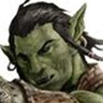
Orc—Orcs are savage and cruel beings who prey on the weak including their own. Male, female, adult, child, orc or not, it doesn't matter in the eyes of an orc, if you're weak you deserve to suffer. Only the strong matter and they can and will take whatever they like from whoever they want, at least until somebody stronger stops them. But the task of taking something, or any task at all, often falls upon the weaker orcs, who will likely pass any task given to them down to those who are weaker than them and so on.
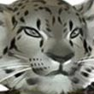
Shapeshifters--Shifters are humans with beastly aspects, both physically as well as mentally. While they can no longer shapeshift completely, they do become more and more beastly during battles, mostly in abilities. Shifters will also think more like animals, often approaching most activities as if it were a hunt. There are 2 types of shifters, the Longtooth and the Razorclaw. The Longtooth shifter is more like bears, they work well in packs, are drawn to hierarchies and will come to the aid of friends and companions. Razorclaw shifters are more like tigers, they're independent, they assume their companions are capable and can take care of themselves just as they can and they will do their best to carry their own weight.
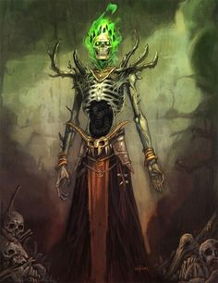
Lich (Undead)— In fantasy fiction, a lich is a type of undead creature. Often such a creature is the result of a transformation, as a powerful magician or king striving for eternal life uses spells or rituals to binding themselves to the Earth. A Lich is a powerful undead being that can control of host of other undead beings including skeletal warriors, zombies, and spirits. Lichs cannot be controlled and are extremely disloyal.

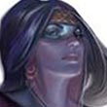
Undine--Undines are humans with an ancestry that traces back to the Plane of Water and it is this ancestry that gives them their blue tinted skins. Like water, undines can be calm and gentle at one point and raging at another, but undines have excellent control over their emotions and will only go into a stage of rage when it is right to do so. Undines love water and will usually live close to it. Despite being land-dwellers they will spend a lot of time in water and dress themselves accordingly. They even prefer weaponry that can be wielded easily in water and is swift.on land.
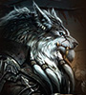
Worgen--The Worgen are cursed humans turned into wolven creatures. They are strong and fast, but lack intelligence due to their animalistic nature. They work best in groups and are dangerous together.

Character Ability Choices
Your character should have one special ability. Choose from the list below:
Magic-user—Can use a variety of spells. Spells exhaust user. Drain energy fast. Can’t defend self at times during a fight, depending on the spell cast.
Warrior—Has armor and superior fighting ability. Deals enormous damage. Wears armor and can take more damage than usual.
Thief—Can steal items #weapons from other characters. Quick and fast. Smooth talker. Intelligent. Stealthy. Can only take limited damage, but skilled fighter.
Cleric—Can heal wounded characters. Weak fighter. Limited skills.
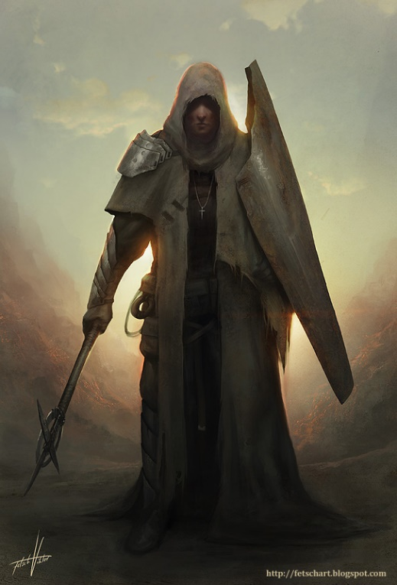
Ranger—Tracker. Knowledgeable about healing and hunting. Good with bow. Skilled fighter.
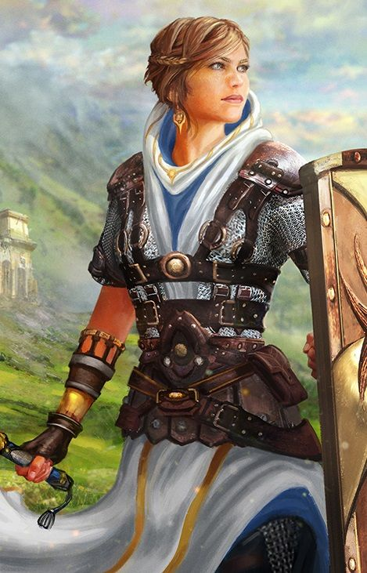
Necromancer—Has dark magic abilities. Can raise undead, but limited. Can summon demons, but low-level ones only.

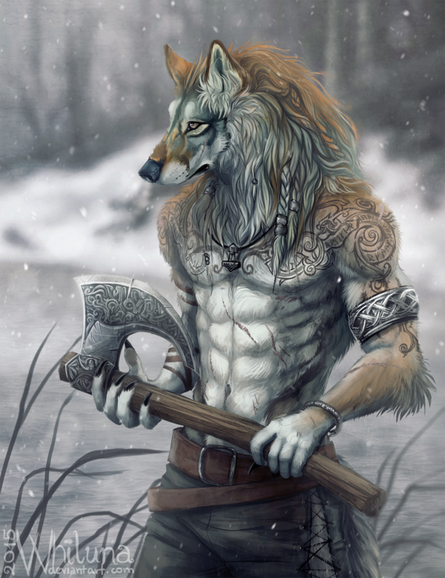

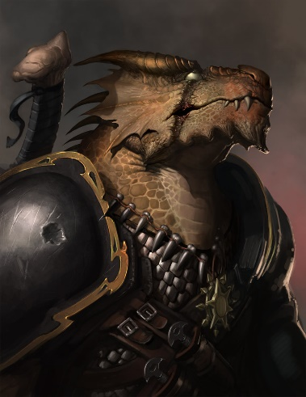

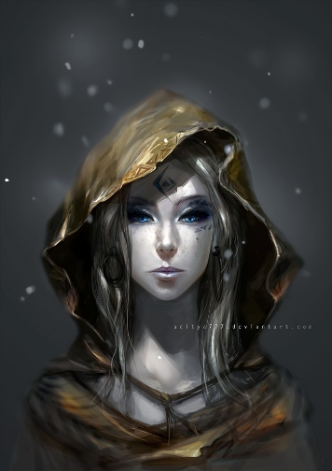
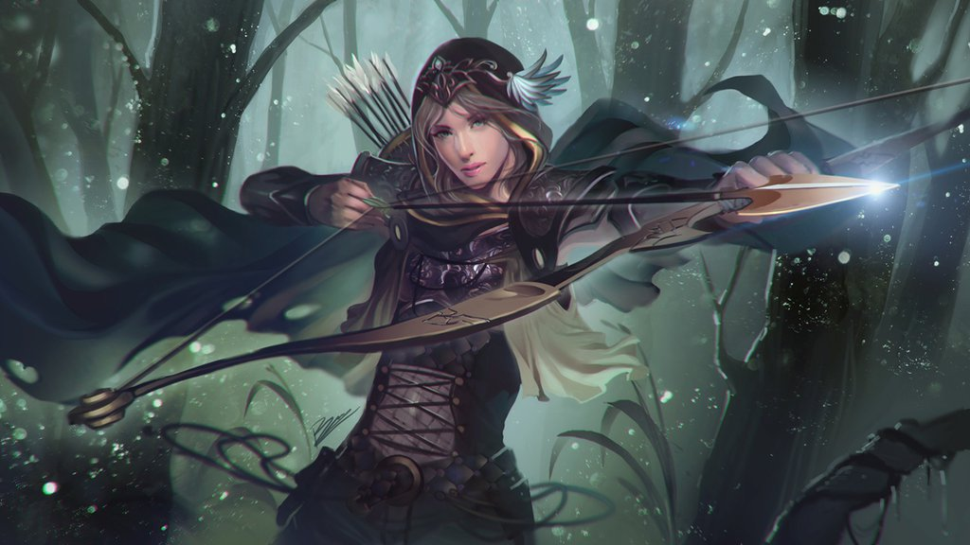

Character Weapon Choices
Your character should have a medieval era weapon. If you choose it to have magical properties, then you can only have one. If you choose a non-magical weapon, then you can have two weapons #SwordAndShield. Choose one from the list below. You may not have a technologically advance weapon nor a specific weapon from any TV show, video game, or Movie (e.g. Excalibur, Mjolnir, Lightsaber, Laser Weapons, Dragonlance, etc.)
Weapon Choices
Hammer: Warhammer, Enchanted Hammer
Cleaving Weapons: Morningstar, Battle Axe, Scythe, Pike, Hatchet/Hand Axe
Sword—Scimitar, Broadsword, Katana, Longsword, Rapier, Bowie Knife, Cutlass, Sai
Shooters: Bow, Crossbow, Poisoned Darts, Musket
Throwers: Sling, Shuriken, Daggers, Spear, Lance, Boomerang
Other: Trident, Net, etc.

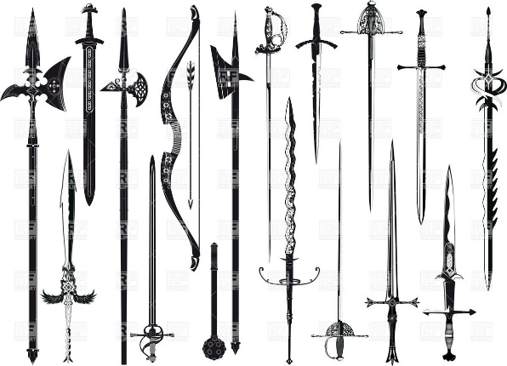
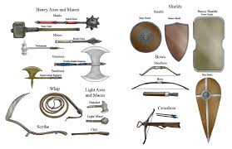

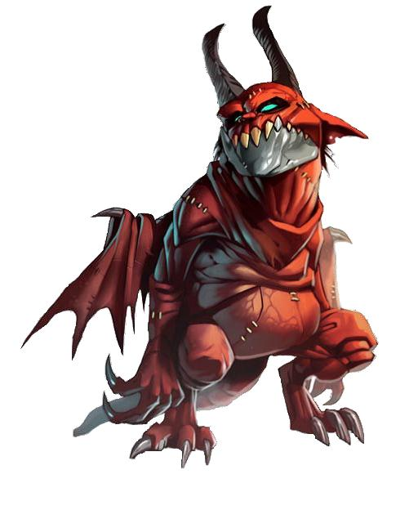
Familiar Choices
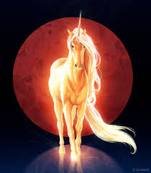
A familiar is a creature that has been magically bound to a person in a master-and-servant type of relationship. The actual type of familiar varies greatly; it is typically a small animal (such as a witch's cat) but can be anything, including demons or even human beings. Similarly, the type of bond can vary: in some cases it is nothing more than the ability to understand what the familiar says (if it speaks) while in others the familiar is the source of the character's powers. But there must be a specific bond; just having a magical creature as a companion doesn't count. The "master" need not be a sorcerer, either — many stories have a normal person gain a familiar by accident, often resulting in trouble. You may propose an animal, but it cannot be a specific animal, like Apa, Charizard, Naga, or Pikachu, etc.
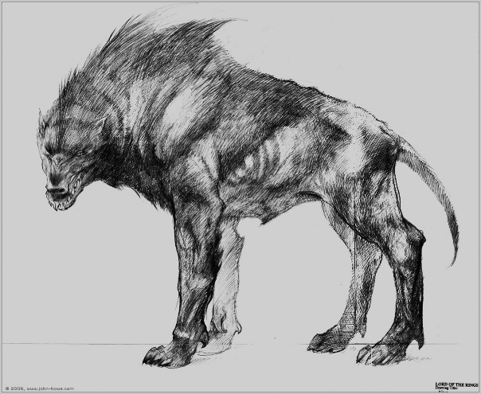
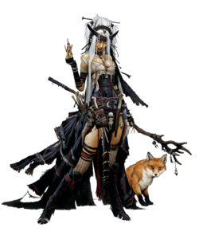
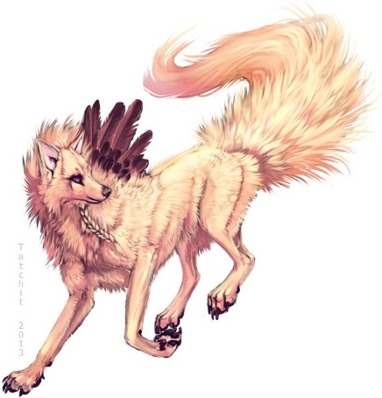
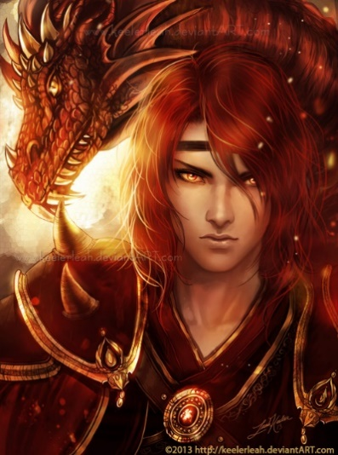

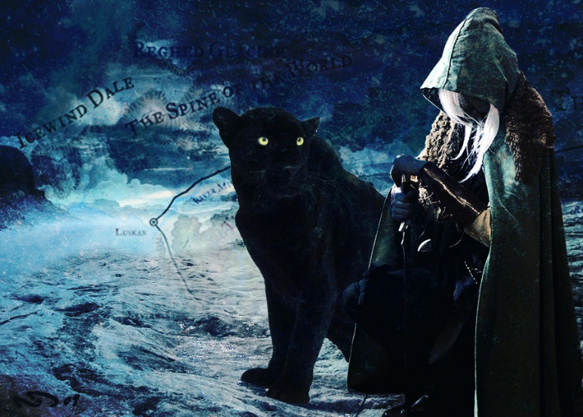

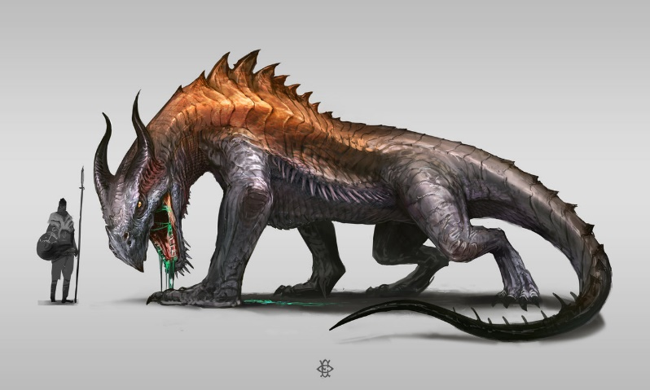

Character Completion
In addition to choosing your character’s race, weapons, abilities, and familiar, you will need to do the following to finish the assignment:
- Rough and Final Draft: Draft your character before finalizing the traits on your character card I gave you last time. Then create your final draft on the card. Write down all of the information below on your drafted paper. Then put it on your character card at the end.
- Demographics: You will want to pick a name, gender, height, weight, profession, homeland, deity/religion, and rank for your character.
- Weapons: Besides picking a weapon, you can also choose two other items to bring with you. These should be non-magical items.
- Arcana: You can bring two magical items with you. These can be things like a cloak of invisibility or a palantir. They just can’t be specific magical items that have been named.
- Characteristics: You should also give your character characteristic scores (see the top left of your fantasy companion paper). These can only add up to 36 total points. You need to give them points on agility, smarts, spirit, strength, and vigor. You should base your scores on your character’s race and abilities.
- Strength: Your character should also have one special personality trait. Choose one of the following: Pace, Parry, Toughness, or Charisma
- Weaknesses: Choose four things that can hinder or slow your character. These could be your characters fears, weaknesses, etc. but be specific. Things like: Magic users, Spiders, Undead, and Lightning could all be options. Put them under hindrance.
- Armor: Choose a piece of armor for your character. Maybe it is a breastplate or just shin-guards. Maybe it is a shield, a fan, or a staff. Maybe it is only a helmet. You can only pick one defensive item, though.
- Picture: Bring a found or drawn picture of your character next time. The picture should be as big as your character card I gave you on cardstock.
- Gather the Fellowship: Before you’ve finished your character, you need to talk to the rest of your table about the character and any ideas they have. Your table becomes your fellowship today. You are a group of wanderers on a quest. You can have anywhere between 3-5 people in your fellowship. We will play a Mr. G-created game with your fellowships soon (as an assignment). Winners get extra credit.
- NOTE: Fill out as much of the character card as you can. There may be some blank space. For example, I haven’t told you how much your items should cost or how much damage they will give. That is okay.

