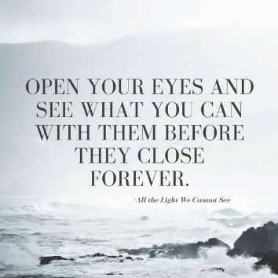
Doerr Historical Narrative Final Project
All the Light We Cannot See

Due: January 3rd
Our point of view shapes how we see the world. We often stereotype people because we don’t understand their point of view. We like to make people out to be either good or evil because we think this way and it is easier to do. However, life isn’t black and white; most of the time, there is a lot of grey. Putting yourself in another’s shoes can help you understand how people have good and bad in them and how grey they are most of the time. Doerr’s imaginative story helps us understand a point of view that we’ve always believed was evil: Nazis. Werner teaches us that the Nazis weren’t all bad and, many times, were extremely conflicted. Your assignment is to find a world perspective that has not been explored thus far in literature and mimic Doerr’s narrative. The angle you choose should be non-American and should explore a historical event that has occurred in the last 100 years. Be creative and have fun choosing your perspective.
The goal is to give us other stories to work from to improve our understanding of events that have happened. The event you choose to write about should be clear in your writing and it should clearly give us a diverse; yet, believable side we’ve never heard from before. A historical narrative requires research, including in-text citations and a works cited page. Your narrative should have enough sources to show you understand the moment well. You should not choose an event you know pretty well because you will not provide enough research to show you’ve learned anything. Since we are mimicking Doerr’s writing style, the narrative should be really compact. Short, but filled with enough information to help us SEE and IMAGINE the experience. You will draft, edit, and revise your Doerr narrative. Write in detail. Use the show, don’t tell strategy we’ve discussed. Utilize great word choice. Implement transitions between your ideas. Make sure that you have paragraphs separating the event into chunks. Help it flow. Your narrative should be one full page, single-spaced. You should draft three separate pieces with extensive revisions on each draft. See the chapter on page 252 in All the Light We Cannot See as an example.

Doerr Historical Narrative Final Project
All the Light We Cannot See

Due: January 3rd
Our point of view shapes how we see the world. We often stereotype people because we don’t understand their point of view. We like to make people out to be either good or evil because we think this way and it is easier to do. However, life isn’t black and white; most of the time, there is a lot of grey. Putting yourself in another’s shoes can help you understand how people have good and bad in them and how grey they are most of the time. Doerr’s imaginative story helps us understand a point of view that we’ve always believed was evil: Nazis. Werner teaches us that the Nazis weren’t all bad and, many times, were extremely conflicted. Your assignment is to find a world perspective that has not been explored thus far in literature and mimic Doerr’s narrative. The angle you choose should be non-American and should explore a historical event that has occurred in the last 100 years. Be creative and have fun choosing your perspective.
The goal is to give us other stories to work from to improve our understanding of events that have happened. The event you choose to write about should be clear in your writing and it should clearly give us a diverse; yet, believable side we’ve never heard from before. A historical narrative requires research, including in-text citations and a works cited page. Your narrative should have enough sources to show you understand the moment well. You should not choose an event you know pretty well because you will not provide enough research to show you’ve learned anything. Since we are mimicking Doerr’s writing style, the narrative should be really compact. Short, but filled with enough information to help us SEE and IMAGINE the experience. You will draft, edit, and revise your Doerr narrative. Write in detail. Use the show, don’t tell strategy we’ve discussed. Utilize great word choice. Implement transitions between your ideas. Make sure that you have paragraphs separating the event into chunks. Help it flow. Your narrative should be one full page, single-spaced. You should draft three separate pieces with extensive revisions on each draft. See the chapter on page 252 in All the Light We Cannot See as an example.

