Partner Assignment: Create your own Star Wars Character
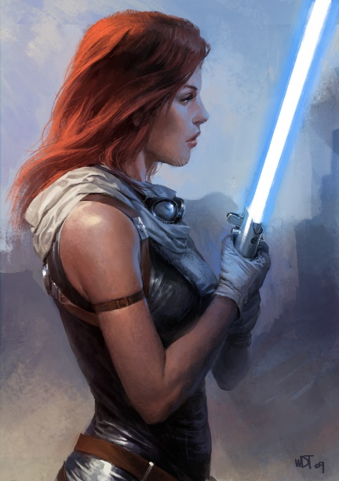
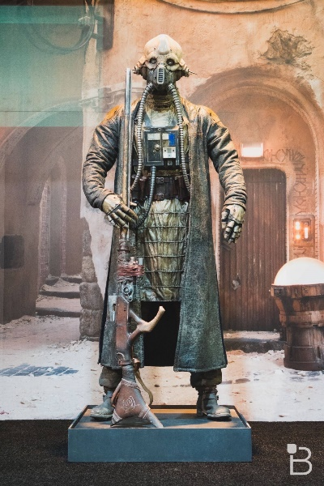
Get with a partner. In preparation for your fanfiction assignment, each of you needs to begin brainstorming ideas for your main character in your fanfiction story. Discuss your story idea with your partner and start brainstorming ideas. You character can be any race and be a part of the rebellion, Empire, Jedi, First Order, or not a part of any group.
On the back side of this paper, write down your character’s name at the top, a LONG list of their personality and characteristics, and, finally, summarize your characters backstory, including the planet they were born on, their life growing up, and how they got to where they are today. Finally, draw a picture of your character. EXTRA CREDIT for awesome drawings and/or writing. Staple this to your paper.

______ Creativity (15 Points)
______ Organization (10 Points)
______ Total Score

Partner Assignment: Create your own Star Wars Character
Get with a partner. In preparation for your fanfiction assignment, each of you needs to begin brainstorming ideas for your main character in your fanfiction story. Discuss your story idea with your partner and start brainstorming ideas. You character can be any race and be a part of the rebellion, Empire, Jedi, First Order, or not a part of any group.
On the back side of this paper, write down your character’s name at the top, a LONG list of their personality and characteristics, and, finally, summarize your characters backstory, including the planet they were born on, their life growing up, and how they got to where they are today. Finally, draw a picture of your character. EXTRA CREDIT for awesome drawings and/or writing. Staple this to your paper.

______ Creativity (15 Points)
______ Organization (10 Points)
______ Total Score

