2017 Lehi High School Battle of the Books Champion
A Beginner’s Guide to
Lehi High School’s
4th Annual Battle of the Books

Name_____________________Team Name_________

Team Member’s Names _________________________
____________________________________________
____________________________________________

Battle of the Books Teacher______________________

Table of Contents

Page 3…………………………..…………..Battle of the Books Master List
Page 4……..…………………….………....Battle of the Books Description
Page 5………………………………………...Battle of the Books Schedule
Page 6……………………………………….Battle of the Books Incentives
Page 7………………. …………...……………Battle of the Books Awards
Page 8……..……………………………….Battle of the Books Champions

2016-2017 “Battle of the Books Master List (16)
Term 1 Selections (4)
I am not a Serial Killer by Dan Wells (R)
I am Malala by Christina Lamb and Malala Yousafzai (N)
Harry Potter and the Cursed Child by JK Rowling, John Tiffany, and Jack Thorne (F/S)
Girl in the Blue Coat by Monica Hesse (H)

Term 2 Selections (4)
Challenger Deep by Neal Shusterman (R)
The Underground Girls of Kabul by Jenny Nordberg (N)
The Night Circus by Erin Morgenstern (F/S)
Wolf by Wolf by Ryan Graudin (H)

Term 3 Selections (4)
We Were Liars by E. Lockhart (R)
Boys in the Boat by Daniel James Brown (N)
The Name of the Wind by Patrick Rothfuss (F/S)
Salt to the Sea by Ruta Sepetys (H)

Term 4 Selections (4)
The Sky is Everywhere by Jandy Nelson (R)
Outliers by Malcolm Gladwell (N)
The Winner’s Curse by Marie Rutkoski (F/S)
In the Time of the Butterflies by Julia Alvarez (Classical) (H)

R—Realistic Fiction
N—Nonfiction
F/S—Fantasy/Science Fiction/Dystopian
H—Historical

“Battle of the Books” Description
Welcome to the 4th annual “Battle of the Books” at Lehi High School. The “Battle of the Books” is a school-wide, yearly competition pitting teams of Lehi High School students against each other in a battle of literary wits. Your team will read the specially-selected books on the master list and battle each other in a Q & A format to show off their mad reading skills. The winning team members will go on to compete in the all-school championship in May. As every English teacher at Lehi is participating this year, you can expect the competition to be highly competitive and the outcome to yield a very deserving winner. Winners receive a trophy, prizes, and bragging rights for an entire year (who wouldn’t want that, right?)

Each team will face off against each other in classroom tournaments at the end of each term with their own English teacher to determine which team(s) get to participate in the end-of-the-year, round-robin Battle of the Books school championship. If you choose to participate in the “Battle of the Books,” you are required to do the following:

Requirements
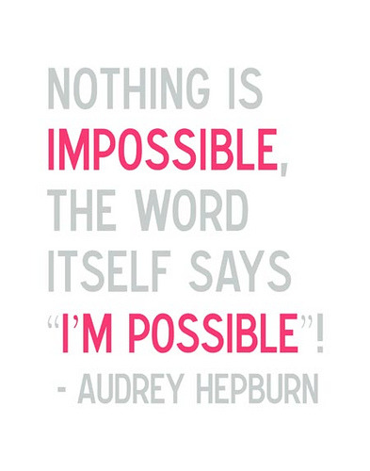
- Be enrolled in a core English class as a sophomore, junior, or senior at Lehi High School
- Form a team of 4 Lehi students (Any grade, any class), come up with a team name, and sign up with your English teacher. Each team must have no less than four and no more than four.
- Dole out, as a team, book assignments—There are 16, which means your team will read four per term. Each team member will read one of the books and become an “expert” on that book. Your English teacher may count this as one of your book reports.
  - Lehi High School doesn’t have most of these books so you will need to find an alternative way to get them (e.g. your local library, Amazon.com, Kindle, Overdrive)
- Participate in your teacher’s class competitions each term to possibly earn a spot in the school championship. Your teacher may run his or her Battle of the Books however he or she sees fit. The end-of-term competitions will be held in your English teacher’s room. The championship will be held in the library. See the schedule for more details.

Battle of the Books Schedule*
August 30 and 31st: Battle of the Books English Presentation
October 21stish: Term 1 “Battle of Books” Qualifier
January 7thish: Term 2 “Battle of the Books” Qualifier
March 17thish: Term 3 “Battle of the Books” Qualifier
May 19thish: “Battle of the Books” Championship in the library

*Dates for qualifiers will be determined and announced by your individual teachers. The championship is set for the second to last week of school in May.

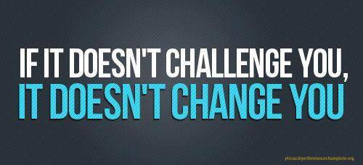

Battle of the Books Assignment

Each of you can participate in the Battle of the Books, but you are not required to do so. If you choose to participate, here is how you will benefit: Instead of a second book report the last half of each term, you will be required to TYPE 10 factual questions (w/ page numbers) AND answers from the Battle of the Books book you read each term. The questions should vary where they show up in the book. For example, you might ask questions from pages 3, 56, 157, 201, 260, 323, and 328, not pages 1, 2, 3, and 4.

An example question might look like the following: “In All the Light We Cannot See, what does Marie-Laure’s father build to help her navigate the city?” NOTE: Make sure that your questions vary in difficulty, too. Other teams will hear and try to answer your questions during the various competitions over the course of the school year. Near the end of each term, your team and class will compete in your competition during Flex or before or after school. Your team will answer questions from all four of the books assigned that term and receive a score based on your answers. You must notify us in advance if you have a school-excused absence because of a field trip or athletic event and turn in your questions early

If, at any time, your team feels that one of your team members is not contributing you may pick up a new student from the pool of non-participating students as a replacement. However, there will be no team-jumping to create dream teams or starting up again after dropping out or not showing up to a Battle.

Battle of the Books Incentives
In the school championship, there will be food, a raffle, and prizes, as well as trophies and medals to the winners. Your individual teachers will determine any extra incentives as a “Battle of the Books” participant. Your participation in the Battle of the Books tournament could also yield the following:
- Attractiveness: You will look more attractive and could possible earn more dating opportunities
- Popularity: Other students at Lehi will look up to you and want to hang out with you
- Credibility: Your legendary exploits will be told for years to come in the halls of Lehi High School

“Battle of the Books” Awards
The winners of the 4th annual “Battle of the Books” will each receive the following:

- A “Battle of the Books Champions” trophy
- Their names engraved on the “Battle of the Books” plaque in the English hallway
- Bragging rights for the rest of your life—winning might even help you get a date one day

Lehi High School Battle of the Books Champions
2014—“Dumbledore’s Army”
Melissa Arnold (Captain)
Emily Elwood
Megan Lethbridge
Lauren Lethbridge

2015—“The Bookaneers”

Ashtyn Josie (Captain)
Clay Christofferson
Mari Lawson
Kelsi Taylor
Brianna

2016—“Assassins Read”

Annie Ogden (Captain)
Caleb Walker
Tanner Wyatt
Matt Russon
McKay Barton

